**CALLBASE PROFILE**

**MODIFICATION TABLE**

|  |  |  |  |
| --- | --- | --- | --- |
| **No** | **Page** | **Content** | **Register date** |
| 1 | all | **Updated profile for all CALLBASE** | 01/2021 |
|  |  |  |  |
|  |  |  |  |
|  |  |  |  |
|  |  |  |  |
|  |  |  |  |
|  |  |  |  |
|  |  |  |  |

|  |  |  |  |
| --- | --- | --- | --- |
| **Prepared by** | **Updated by** | **Verified by** | **Approved by** |
| XXXXX  **IT Operation Staff** | **IT Operation** | XXXXXXX  **Chief of IT department** | XXXXXXX  **Vice Director of IT** |

1. **SYSTEM OVERVIEW**
   1. **Project Name:** CALLBASE
   2. **Developed by:** PARTNER  BITEL (IN-HOUSE)
   3. **Service Owner:**  BITEL
   4. **Description**

CALLBASE system obtain the subscriber’s call state and ussd transaction information in real time by collecting SS7 signaling through signaling monitoring mechanism. The collection point is between Intelligent Network and core network.

This data will pubslish to Kafka, Database or CDR files.

1. **LOGICAL MODEL**
   1. **Logical diagram**

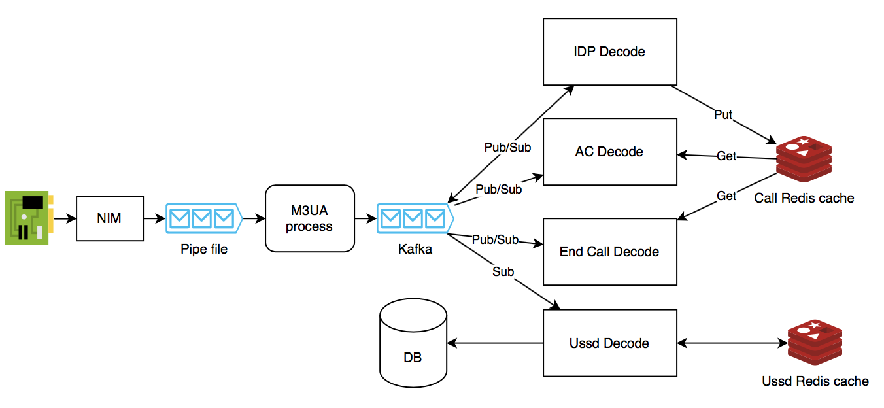

* **NIM:** This module will capture all signaling. On Network Interface Card. This signaling will be filter and put to fifo file (Pipe file).

*Note: This module run on root user or sudo permission*

* **Pipe file:** This is fifo file.
* **M3UA Process:** This module gets signaling from Pipe file, then publish to Kafka on Topic “m3ua”
* **IDP Decode:** This module subscribes kafka on topic “m3ua” to get signaling. This decode TCap-Begin Signaling to detect calling – called on Call Init event. Call information will publish to Kafka on topic “call_init” and save on Redis cache.
* **AC Decode:** This module subscribes kafka on topic “m3ua” to get signaling. This decode TCap-Continue Signaling to detect “Run out of money” event. This get call information from Redis cache and publish to Kafa on topic “call_release_acr”.
* **End call Decode:** This module subscribes kafka on topic “m3ua” to get signaling. This decode TCap-End signaling to detect “Run out of money” event. This get call information from Redis cache and publish to Kafa on topic “call_end”.
* **Ussd Decode:** This module subscribes kafka on topic “m3ua” to get signaling.

With TCap-Begin signaling, it detects ussd request, then save in Redis cache.

With TCap-End signaling, it detects ussd response and get get transaction information from Redis cache.

Ussd Transaction include Calling, Command, Response message will be saved to Database on table trans_ussd.

* 1. **Physical model**

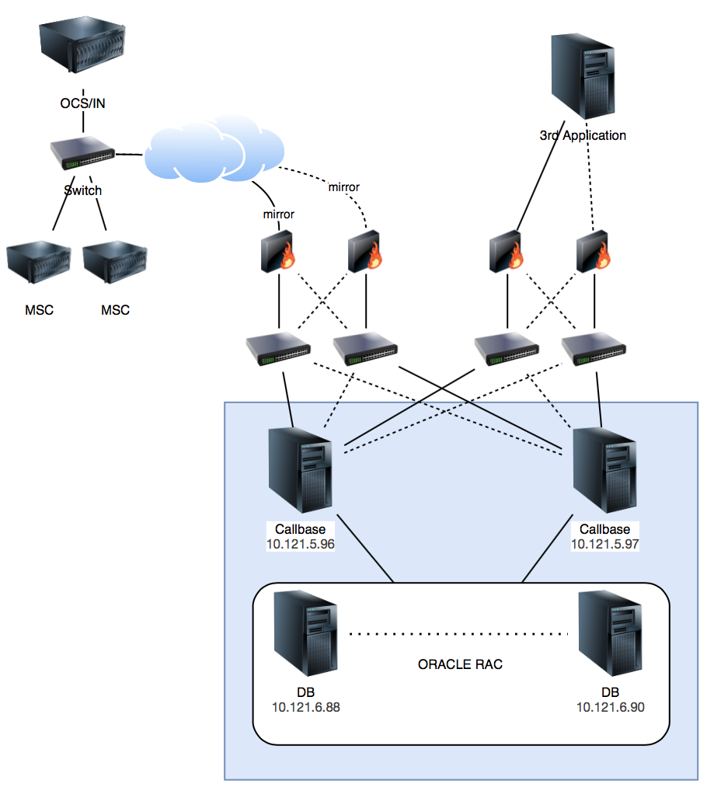

|  |  |  |  |
| --- | --- | --- | --- |
| STT | IP | Type | Description |
| 1 | 10.121.5.96 | Application | Include NIM, M3UA Process, IDP Decode, AC Decode, End Call Decode, USSD Decode, Kafka, Redis.  Pipe file created on these servers also. |
| 2 | 10.121.5.97 |
| 3 | 10.121.6.88 | Database | Oracle Database |
| 4 | 10.121.6.90 |

* 1. **Modules description**

|  |  |  |  |  |  |  |  |
| --- | --- | --- | --- | --- | --- | --- | --- |
| **Module** | **Description** | **IP server** | **Setup dir** | **Config dir** | **Log path** | **MM Port** | **Mode** |
| NIM | Capture signaling on network card | 10.121.5.96 | /u01/app/callbase/NIM1.2 | /u01/app/callbase/NIM1.2/etc | /u01/app/callbase/NIM1.2/log | N/A | Active |
| NIM | Capture signaling on network card | 10.121.5.97 | /u01/app/callbase/NIM1.2 | /u01/app/callbase/NIM1.2/etc | /u01/app/callbase/NIM1.2/log | N/A | Standby |
| M3UA Process | Read signaling from Pipe and push to Kafka | 10.121.5.96 | /u01/app/callbase/m3uaDecode | /u01/app/callbase/m3uaDecode/etc | /u01/app/callbase/m3uaDecode/logs/full | N/A | Active |
| M3UA Process | Read signaling from Pipe and push to Kafka | 10.121.5.97 | /u01/app/callbase/m3uaDecode | /u01/app/callbase/m3uaDecode/etc | /u01/app/callbase/m3uaDecode/logs/full | N/A | Active |
| Kafka | Kafka queue | 10.121.5.96 | /u01/app/callbase/kafka | /u01/app/callbase/kafka/config | /u01/app/callbase/kafka/logs | N/A | Active |
| Kafka | Kafka queue | 10.121.5.97 | /u01/app/callbase/kafka | /u01/app/callbase/kafka/config | /u01/app/callbase/kafka/logs | N/A | Active |
| IDP Decode node 1 | Module decode initial call signaling | 10.121.5.96 | /u01/app/callbase/idpDecode/node1 | /u01/app/callbase/idpDecode/node1/etc | /u01/app/callbase/idpDecode/node1/logs/full | N/A | Active |
| IDP Decode node 2 | Module decode initial call signaling | /u01/app/callbase/idpDecode/node2 | /u01/app/callbase/idpDecode/node2/etc | /u01/app/callbase/idpDecode/node2/logs/full | N/A | Active |
| IDP Decode  Node 1 | Module decode initial call signaling | 10.121.5.97 | /u01/app/callbase/idpDecode/node1 | /u01/app/callbase/idpDecode/node1/etc | /u01/app/callbase/idpDecode/node1/logs/full | N/A | Active |
| IDP Decode  Node 2 | Module decode initial call signaling | /u01/app/callbase/idpDecode/node2 | /u01/app/callbase/idpDecode/node2/etc | /u01/app/callbase/idpDecode/node2/logs/full | N/A | Active |
| AC Decode  Node 1 | Module decode Apply charging signaling | 10.121.5.96 | /u01/app/callb ase/acDecode/node1 | /u01/app/callbase/acDecode/node1/etc | /u01/app/callbase/acDecode/node1/logs/full | N/A | Active |
| AC Decode  Node 2 | Module decode Apply charging signaling | /u01/app/callbase/acDecode/node2 | /u01/app/callbase/acDecode/node2/etc | /u01/app/callbase/acDecode/node2/logs/full | N/A | Active |
| AC Decode  Node 1 | Module decode Apply charging signaling | 10.121.5.97 | /u01/app/callbase/acDecode/node1 | /u01/app/callbase/acDecode/node1/etc | /u01/app/callbase/acDecode/node1/logs/full | N/A | Active |
| AC Decode  Node 2 | Module decode Apply charging signaling | /u01/app/callbase/acDecode/node2 | /u01/app/callbase/acDecode/node2/etc | /u01/app/callbase/acDecode/node2/logs/full | N/A | Active |
| End Call Decode  Node 1 | Module decode End call signaling | 10.121.5.96 | /u01/app/callb ase/endCallDecode/node1 | /u01/app/callbase/endCallDecode/node1/etc | /u01/app/callbase/endCallDecode/node1/logs/full | N/A | Active |
| End Call Decode  Node 2 | Module decode End call signaling | /u01/app/callbase/endCallDecode/node2 | /u01/app/callbase/endCallDecode/node2/etc | /u01/app/callbase/endCallDecode/node2/logs/full | N/A | Active |
| End Call Decode  Node 1 | Module decode End call signaling | 10.121.5.97 | /u01/app/callbase/endCallDecode/node1 | /u01/app/callbase/endCallDecode/node1/etc | /u01/app/callbase/endCallDecode/node1/logs/full | N/A | Active |
| End Call Decode  Node 2 | Module decode End call signaling | /u01/app/callbase/endCallDecode/node2 | /u01/app/callbase/endCallDecode/node2/etc | /u01/app/callbase/endCallDecode/node2/logs/full | N/A | Active |
| USSD Decode  Node 1 | Module decode ussd request and response message | 10.121.5.96 | /u01/app/callb ase/ussdDecode/node1 | /u01/app/callbase/ussdDecode/node1/etc | /u01/app/callbase/ussdDecode/node1/logs/full | N/A | Active |
| USSD Decode  Node 2 | Module decode ussd request and response message | /u01/app/callbase/ussdDecode/node2 | /u01/app/callbase/ussdDecode/node2/etc | /u01/app/callbase/ussdDecode/node2/logs/full | N/A | Active |
| USSD Decode  Node 1 | Module decode ussd request and response message | 10.121.5.97 | /u01/app/callb ase/ussdDecode/node1 | /u01/app/callbase/ussdDecode/node1/etc | /u01/app/callbase/ussdDecode/node1/logs/full | N/A | Active |
| USSD Decode  Node 2 | Module decode ussd request and response message | /u01/app/callbase/ussdDecode/node2 | /u01/app/callbase/ussdDecode/node2/etc | /u01/app/callbase/ussdDecode/node2/logs/full | N/A | Active |
| Redis | Redis cache | 10.121.5.96 | /usr/local/bin | /etc/redis/ |  | N/A | Master |
| Redis | Redis Cache | 10.121.5.97 | /usr/local/bin | /etc/redis/ |  | N/A | Slave |

1. **DATABASE MODEL**

**PROVIDE FULL DB DETAIL: DB, Schemas, Tables, among other dependencias (procedurs, packages, triggers, views, functions, etc)**

* 1. **Database description**

|  |  |  |  |
| --- | --- | --- | --- |
| **N°** | **Application** | **DB** | **Description** |
| 1 | Ussd Decode | Callbase | Schema: XXX Tables: 1) TRANS_USSD: Holds all USSD transaction query balance (*121#, *122#). |

1. **Connection Descriptions**

|  |  |  |  |
| --- | --- | --- | --- |
| **N°** | **From** | **To** | **Protocol** |
| 1 | USSD Decode  10.121.5.96  10.121.5.97 | DB Oracle  10.121.6.88  10.121.6.90 | TCP |
| 2 | All Callbase Applications  10.121.5.96  10.121.5.97 | Redis  10.121.5.96  10.121.5.97 | TCP |
| 3 | All Callbase Applications  10.121.5.96  10.121.5.97 | Kafka  10.121.5.96  10.121.5.97 | TCP |

1. **SIZING**
   1. **Callbase Applications**

|  |  |  |  |
| --- | --- | --- | --- |
| **Server** | **Resource** | **Description** | **Qty** |
| 10.121.5.96 | CPU | Intel(R) Xeon(R) CPU E5-2630 v3 @ 2.40GHz | 1 |
| Cores | 12 | 1 |
| Ram | 62 GB | 1 |
| HDD | 500 GB | 1 |
| 10.121.5.97 | CPU | Intel(R) Xeon(R) CPU E5-2630 v3 @ 2.40GHz | 1 |
| Cores | 12 | 1 |
| Ram | 62 GB | 1 |
| HDD | 500 GB | 1 |

1. **OPERATION MANUAL**
2. NIM
   1. **Start NIM**

* cd /u01/app/callbase/NIM1.2/bin
* sudo ./start  
  1. **Stop NIM**
* cd /u01/app/callbase/NIM1.2/bin
* sudo ./stop

1. **M3UA Process**
   1. **Start M3UA Decode**

* cd /u01/app/callbase/m3uaDecode/bin
* ./runner start
  1. **Stop M3UA Decode**
* cd /u01/app/callbase/m3uaDecode/bin
* ./runner stop
  1. **Restart M3UA Decode**
* cd /u01/app/callbase/m3uaDecode/bin
* ./runner restart
  1. **Check Log**
* cd /u01/app/callbase/m3uaDecode//logs/full
* tail –f ./full.log

1. **IDP Process node 1**
   1. **Start IDP Decode**

* cd /u01/app/callbase/idpDecode/node1/bin
* ./runner start
  1. **Stop IDP Decode**
* cd /u01/app/callbase/ idpDecode/node1/bin
* ./runner stop
  1. **Restart IDP Decode**
* cd /u01/app/callbase/ idpDecode/node1 /bin
* ./runner restart
  1. **Check Log**
* cd /u01/app/callbase/ idpDecode/node1//logs/full
* tail –f ./full.log

1. **IDP Process node 2**
   1. **Start IDP Decode**

* cd /u01/app/callbase/idpDecode/node2/bin
* ./runner start
  1. **Stop IDP Decode**
* cd /u01/app/callbase/ idpDecode/node2/bin
* ./runner stop
  1. **Restart IDP Decode**
* cd /u01/app/callbase/ idpDecode/node2 /bin
* ./runner restart
  1. **Check Log**
* cd /u01/app/callbase/ idpDecode/node2//logs/full
* tail –f ./full.log

1. **AC Process node 1**
   1. **Start AC Decode**

* cd /u01/app/callbase/acDecode/node1/bin
* ./runner start
  1. **Stop AC Decode**
* cd /u01/app/callbase/acDecode/node1/bin
* ./runner stop
  1. **Restart AC Decode**
* cd /u01/app/callbase/acDecode/node1 /bin
* ./runner restart
  1. **Check Log**
* cd /u01/app/callbase/acDecode/node1//logs/full
* tail –f ./full.log

1. **AC Process node 2**
   1. **Start AC Decode**

* cd /u01/app/callbase/acDecode/node2/bin
* ./runner start
  1. **Stop AC Decode**
* cd /u01/app/callbase/ acDecode /node2/bin
* ./runner stop
  1. **Restart AC Decode**
* cd /u01/app/callbase/ acDecode /node2 /bin
* ./runner restart
  1. **Check Log**
* cd /u01/app/callbase/ acDecode /node2//logs/full
* tail –f ./full.log

1. **End Call Process node 1**
   1. **Start End Call Decode**

* cd /u01/app/callbase/endCallDecode/node1/bin
* ./runner start
  1. **Stop End Call Decode**
* cd /u01/app/callbase/endCallDecode/node1/bin
* ./runner stop
  1. **Restart End Call Decode**
* cd /u01/app/callbase/endCallDecode/node1 /bin
* ./runner restart
  1. **Check Log**
* cd /u01/app/callbase/endCallDecode/node1/logs/full
* tail –f ./full.log

1. **End Call Process node 2**
   1. **Start End Call Decode**

* cd /u01/app/callbase/ endCallDecode /node2/bin
* ./runner start
  1. **Stop End Call Decode**
* cd /u01/app/callbase/ endCallDecode /node2/bin
* ./runner stop
  1. **Restart End Call Decode**
* cd /u01/app/callbase/ endCallDecode /node2 /bin
* ./runner restart
  1. **Check Log**
* cd /u01/app/callbase/ endCallDecode /node2//logs/full
* tail –f ./full.log

1. **Ussd Process node 1**
   1. **Start Ussd Decode**

* cd /u01/app/callbase/ussdDecode/node1/bin
* ./runner start
  1. **Stop Ussd Decode**
* cd /u01/app/callbase/ ussdDecode /node1/bin
* ./runner stop
  1. **Restart Ussd Decode**
* cd /u01/app/callbase/ ussdDecode /node1 /bin
* ./runner restart
  1. **Check Log**
* cd /u01/app/callbase/ ussdDecode/node1/logs/full
* tail –f ./full.log

1. **Ussd Process node 2**
   1. **Start Ussd Decode**

* cd /u01/app/callbase/ ussdDecode /node2/bin
* ./runner start
  1. **Stop Ussd Decode**
* cd /u01/app/callbase/ ussdDecode /node2/bin
* ./runner stop
  1. **Restart Ussd Decode**
* cd /u01/app/callbase/ ussdDecode /node2 /bin
* ./runner restart
  1. **Check Log**
* cd /u01/app/callbase/ ussdDecode /node2//logs/full
* tail –f ./full.log

1. **DDITIONAL INFORMATION**

**Language:** Java/C

**Support High Availability:** YES

1. **OPERATIONAL SUPPORT SERVICE**

If the responsible finds that the issue cannot be solved at their level, then it should be escalated to the next level and they can work on it for the allotted time.

|  |  |  |  |  |
| --- | --- | --- | --- | --- |
| **ESCALATION MATRIX** | | | | |
| **Level** | **Responsible** | **Time Response** | **Contact** | **Description** |
| **L1** | Check the progress | <=1.5 hours | Mr. Hoi, hoihoang@arabicatech.vn | coordinate support to build more nodes, check whether the process is suspended or not |
| **L2** | Check for errors related to software, source code | <=1.5 hours | Mr. Hung, cto@arabicatech.vn | Collaborate to check for software-related errors, if any |